**Life Recipe**

Kim sihoon, Jeong chaerin, Kim kyungwook

Green-apple(Choroksagwa), Korea, kgu011016@gmail.com

Abstract

It was created as a website for users to use comfortably. As for the language, JAVA and HTML (JSP) were mainly used. The appearance of the web page was written in HTML language, and internal functions (databases, etc.) were written in JAVA language. The information stored in the database is member information (ID, password, gender, etc.) and post information (heading, content, date of creation, etc.).

Background & Purpose

Life Recipe is a website that explains everyday common sense that is small enough to be forgotten in life but important. The reason why we created this site was that while looking for items to develop, a team member said, "I wish there was a program to collect and find daily common sense," and produced the program. Specifically, funeral courtesy and wedding courtesy are included as examples.

Concept & Idea

The idea of this program is a wiki-type website that anyone can access. Literally, the final goal is a site where anyone can see and edit posts. Therefore, it is most important to create a site that users can conveniently use. Life Recipe consists of membership registration, login, main, and notice board pages. For the convenience of users, the main space, the notice board page, allows the title and author of the post to be immediately visible, and if more than 10 articles are posted on one page, it will be shown on the next page.

Design & Functions

1. The upper bar of the main page includes a main, a notice board, and a connection button. The notice board button moves to a page where a post can be written (described in No. 3). The access button is divided into membership registration and login (described in No. 2).

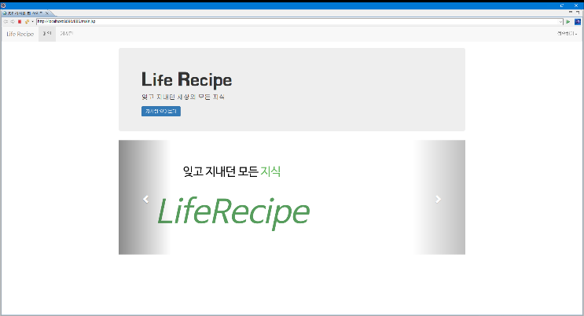

Figure 1 1. Main Page

2-1. If you press the buttons in order of main page -> access -> membership registration, the page for membership registration will open. It is ID, password, name, gender, and e-mail in order from the top. In this case, the input information is moved to the member information database.

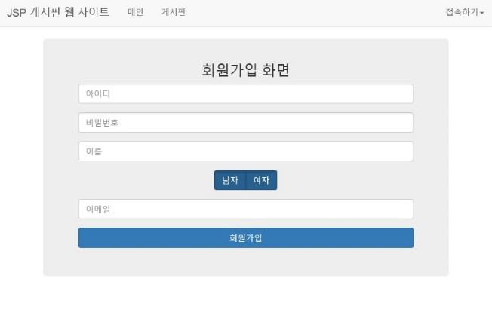

Figure 2 Membership Page

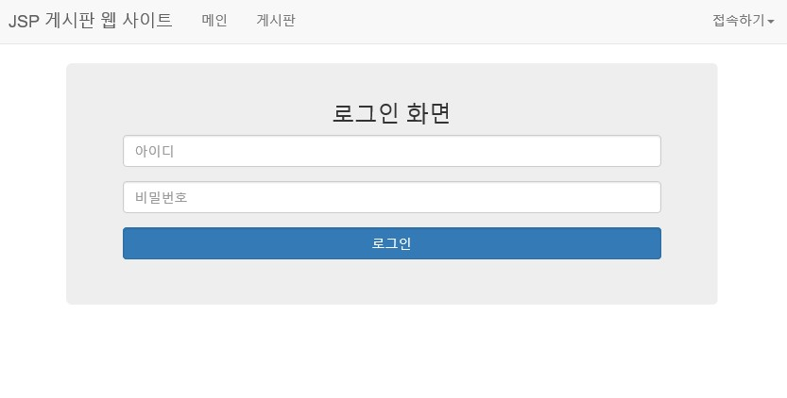2-2. When buttons are pressed in order of main page->access->login, a page for login is opened. You can log in by entering your ID and password.

Figure 3 Login Page

1. Pressing the notice board button opens the page as shown in ‘Figure 4’. Pressing the 'Writing' button on the page opens the page as shown in ‘Figure 5’. Only the author can delete and modify the created post.

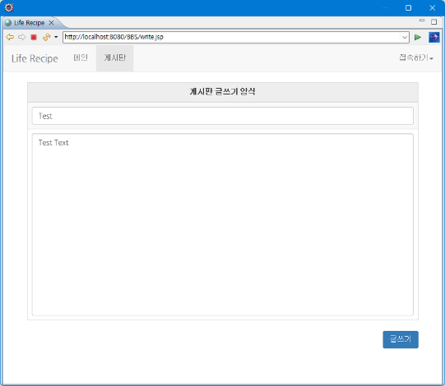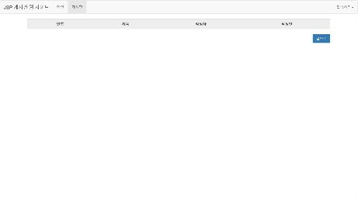

Figure 4 Notice Board

Figure 5 Post

Problems & Future work

Since the target function has not yet been implemented, the first goal will be to implement the function. The functions to be implemented are specific categories, search, recommendation/non-recommendation, and discussion functions. Adding two functions will make it easier for users to use as a whole. We also want to implement a function that recommends search terms by reflecting posts pressed by users.